School attendance and mental wellbeing

DELEGATE HANDBOOK
Contents
Welcome to Anna Freud 3
Learning outcomes 4
Module 1: What is the link between school attendance and mental wellbeing? 5
Module 2: A Whole-School Approach to attendance and mental wellbeing 10
Module 3: Strategies 11
Next steps 24
Reading list 25
Acknowledgements 26
Appendix 27
Notes 34

Welcome to Anna Freud!
We are a mental health charity working with thousands of schools and FE colleges. We are based in the UK but work internationally with our vision for all schools and colleges to be mentally healthy.
We are here to help. Through our evidence-based training, research and resources we support education staff to adopt a whole-school or college approach to mental health and wellbeing, putting it at the heart of their communities.
We recognise that discrimination and inequality undermine the opportunity for every child to thrive. We aim to be ambitious in driving change in ourselves and supporting change in those we work with, towards a more equitable society.
We hope to offer some current perspectives and practical suggestions that you can share with colleagues back at school/college.

Learning outcomes
By the end of today’s training session, you will have:
- Further understanding of school attendance and mental wellbeing.

- Recognised the positive impact of using a relational approach.

- Increased awareness of the perspectives of children, young people and families who have personal experience of EBSA.

- Deepened understanding of evidence-based interventions and strategies to use as part of a whole school approach.

- Experience of selecting appropriate resources to assess and plan support school attendance and mental wellbeing.

Module 1: What is the link between school attendance and mental wellbeing?
Use this section to write answers and additional notes alongside the activities during today’s training session.

Activity 1: Your ‘journey’ here today
- Why this training and why you?

Activity 2: What is your local offer?
- Research what local support is available to you:
Consider:
- Local authority attendance team
- MAT/academy trust
- Educational psychology team
- Charities/other

Activity 3: The voices of children and young people
Young Champions: Emily and Kelly

- How did the video make you feel?
- What can we learn from the video?

Risk and protective factors word map
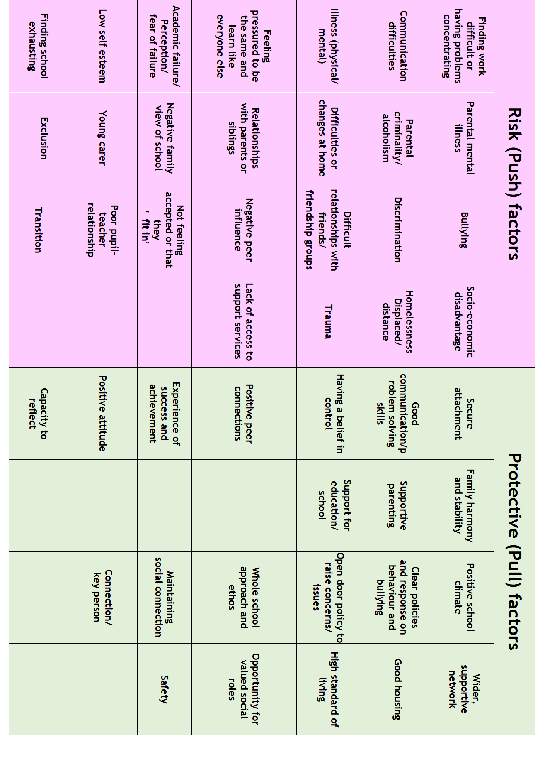
Activity 4: Considering those who might be at greater risk
- In your setting, can you think of any particular children and young people who may be more vulnerable?
- Why might this be?

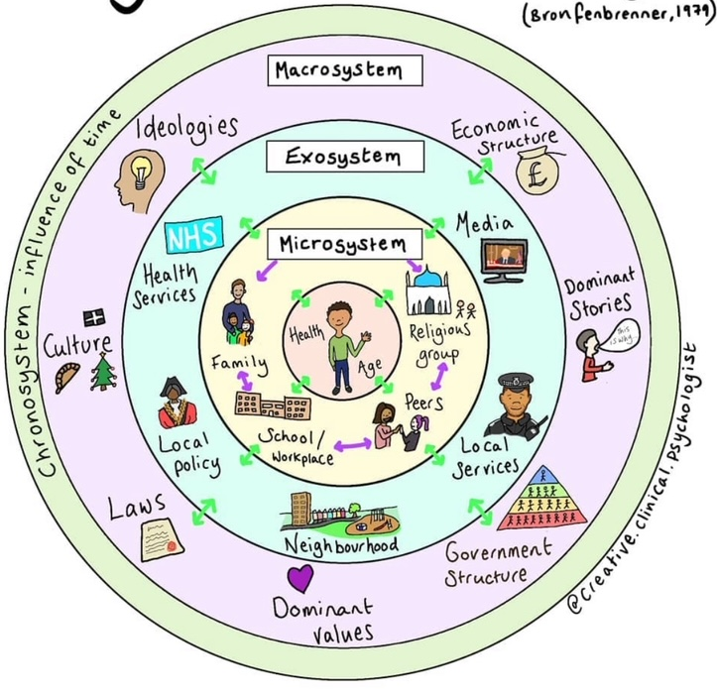

(Image: Dr. Juliet Young)
Activity 5: Enhancing protective factors
- What protective factors can the school environment offer?

You might think about this in terms of:
- Individual factors.
- Family factors.
- Community.
- Learning environments.

Activity 6: The voice of the school
School Champion: Ben

- What can we take from Ben’s approach?

Module 2: A Whole-School Approach

Activity 7: Reflect on your current whole school approach
- What would be a priority area for your setting?

- Whole school training?
- Ethos?
- Policy?
- Which do you prioritise and how?

Activity 8: The voices of the parents
Parent Champions: Nicola and Lorna

- How did the video make you feel?
- What can we learn from the video?

Activity 9: Reflect on the videos we have watched today
- Using your word maps, what have you taken away from these experiences?

Module 3: Strategies

Thinking holistically
- Risk and protective factors.
- Considering the systems around the family allows us to highlight gaps in our understanding and approach the situation more pragmatically.
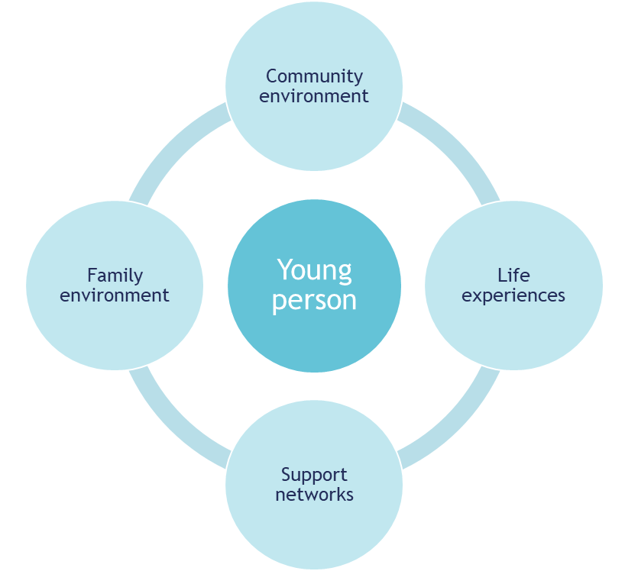
- Reducing the potential for our own biases and emotions to creep into the conversation.
- Allowing for more tailored and personalised support and addressing any barriers from the outset.

Activity 10: Assess (Laylas case study)
Layla is 15 and is academically capable. Ever since she returned to school from lockdown her attendance has been inconsistent. She is a quiet student but used to have a small group of reliable friends and has always completed her classwork and homework to a high standard.
More recently her approach to her work has become less enthusiastic. Teachers have noticed that her moods can be variable. Some days she seems happy and gets on well in class, other days she’s very quiet, lacks concentration and doesn't seem to want to participate in anything. She has begun to forget to complete homework and doesn’t have much to say when asked about it.
She has asked to move seats in two of her subjects. She told one teacher that she thinks thinks people are judging her. For a while at the start of the year she asked her form tutor if she could stay in her classroom at lunch time but that teacher has now gone on maternity leave. She frequently brings notes excusing her from PE.
Layla lives at home with her mum, dad and older brother. Her parents both work in the health service doing stressful and demanding jobs. Her older brother is in 6th form studying A levels. He is an academic high achiever, but experienced significant homophobic and racist bullying lower down in the school. Layla has a very strong relationship with her maternal grandparents who live nearby. Her grandfather retired from work recently because of ill health. Layla worries about him but also enjoys spending time with him.
When they were at primary school, Layla and her brother witnessed a violent street incident resulting in the death of a teenager. Layla and her parents declined the school’s offer of mental health support at that time.
Recently Layla’s attendance has become a more serious concern. Attendance on Mondays is particularly poor. On other days of the week she frequently comes in to school late. Often her mum has to bring her and Layla sometimes becomes distressed after her mum leaves. She will usually calm down quickly and then attend classes. However, she very frequently asks to leave lessons for various reasons.
Last week Layla had a dispute with a teacher because she was using her mobile phone during the lesson. Layla shouted at the teacher and wouldn’t hand her phone over as required by school rules. She left the classroom and then went home without permission. Layla has not come to school since.
Another student has confided in a member of staff they saw cut marks on Layla’s arm. Layla doesn’t seem to spend much time with her former friends.

5 P’s formulation template

Activity 11: Function of non-attendance
Look through the resources on your table and consider:
- What do you like/dislike about these?
- Which would be most appropriate for your setting and why?

Activity 12: Mapping the school landscape
Look through the resources on your table and consider:
- Physical environment
- Social environment
- Learning environment

- Can we use this information to begin to make ‘reasonable adjustments’?
- Considering sensory needs?

Activity 13: Plan (Layla’s case study)
- How can you support Layla to successfully reintegrate back into school?
- What things would you need to consider?

Activity 14: Do (Laylas case study)
- Are there any specific interventions that come to mind for Layla?

Now think about your current whole-school approach to mental wellbeing.

- What interventions do you already use?
- Are they applicable to supporting a CYP with emotionally based school avoidance?

Activity 15: Case studies
Case study 1 – Mateo

Mateo is a 5 year old boy. He has just moved to the area with his mum, joining the school in the middle of the Autumn term. His mum recently lost her job and so moved to be closer to family.
Mateo is generally well-behaved in class and in school. He is polite and appears to enjoy learning; he would be considered academically able.
Mateo has become particularly friendly with one other child but otherwise comes across as quite shy and insular; he often looks unsure and unhappy if that friend isn't at school.
When Mum drops him off at school he becomes visibly upset when she tries to leave, refusing to let go of his mum. Often, staff have to physically lead Mateo into school. Lunchtime supervisors have reported to Mateo's teacher that he often complains of a tummy ache at lunchtime.

Notes:

Case study 2 – Fatima

Fatima is a 15-year-old girl at secondary school. She would be considered a high achiever and very academic. Both her parents are heavily invested in her education and are both doctors in the local village. Fatima doesn't appear to have a solid friendship group and in class appears withdrawn and often looks unhappy.
It has been observed that at lunchtime she goes to the toilets and cries. She presents as being quite closed off and reluctant to speak and reports to tutor that she experiences heightened anxiety and panic when asked to speak in front of others.
Fatima's attendance is at 75% and school are concerned. Fatima says that she feels sick as the reason she doesn’t want to go to school. Mum encourages her to go to school and would tell her to ‘buck up’ and get on with things.

Notes:

Activity 13: Task
- Carry out a formulation using the 5Ps:

- Work out the function of avoidance:

- Consider and select appropriate assessment tools that you would use, in order to…

- Create a plan, incorporating elements of the whole-school approach and including any interventions that might be necessary:

- Present back and justify choice of tools, using the 'Assess/Plan/Do/ Review' structure:

Assess, plan, do, review template
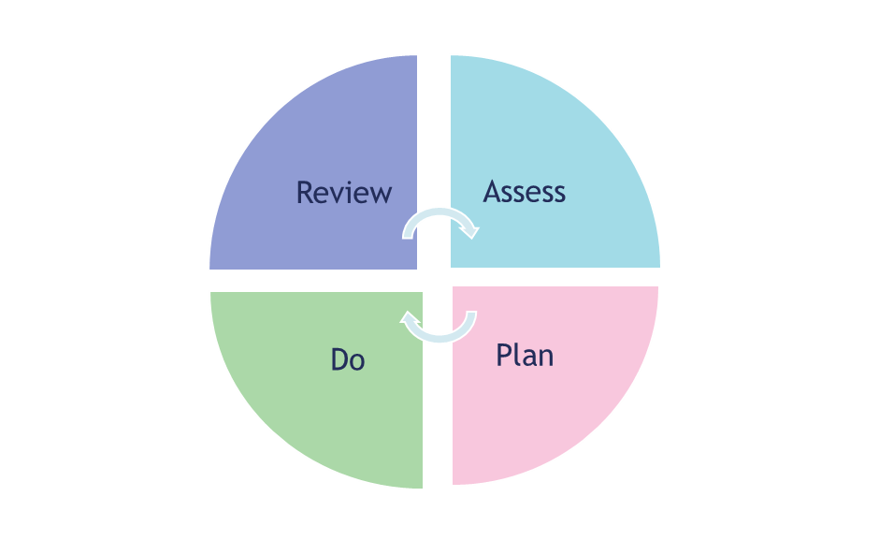

Next steps checklist
Use this section to assist you in preparing for next steps.
Checklist
Date: | To do:  Carry out whole-school audit.  Ensure policies are robust.  Mapping your local offer and points of contact.

Reading list
Guidance documents:
1. | Working together to improve school attendance | https://www.gov.uk/government/publications/working-together-to-improve-school-attendance | Notes
2. | Mental health issues affecting a pupil's attendance: guidance for schools | https://www.gov.uk/government/publications/mental-health-issues-affecting-a-pupils-attendance-guidance-for-schools
3. | Transforming children and young people's mental health provision a green paper | https://www.gov.uk/government/consultations/transforming-children-and-young-peoples-mental-health-provision-a-green-paper
4. | Promoting children and young people's mental health and wellbeing | https://assets.publishing.service.gov.uk/government/uploads/system/uploads/attachment_data/file/1020249/Promoting_children_and_young_people_s_mental_health_and_wellbeing.pdf
5. | Social, emotional and mental wellbeing in primary and secondary education NICE guidelines | https://www.nice.org.uk/guidance/ng223/resources/social-emotional-and-mental-wellbeing-in-primary-and-secondary-education-pdf-66143833987525
6. | Resources for families | https://www.childrenscommissioner.gov.uk/back-into-school/resources-for-families/

Recommended reading and resources:

- Schools in Mind
Sign up for monthly newsletter updates about our resources, training, research and more.
https://www.annafreud.org/resources/schools-and-colleges/schools-in-mind/

- Mentally Healthy Schools
Access hundreds of free, clinically assured mental health resources and information for schools and colleges.
www.mentallyhealthyschools.org.uk/

- Anna Freud Centre
Access our resources for schools and colleges
www.annafreud.org/schools-and-colleges/resources/

- Anti-racism and mental health in schools
www.annafreud.org/schools-and-colleges/anti-racism-and-mental-health-in-schools/

- 5 Steps to Mental Health and Wellbeing
www.annafreud.org/schools-and-colleges/5-steps-to-mental-health-and-wellbeing/

Acknowledgements

The development of this training could not have been done without the help of the various local authorities who kindly shared their best practice with us:
- Bromley
- Bucks
- Essex
- Lancashire
- Lincolnshire
- Salford
- Solihull
- Staffordshire
- Sutton (Cognus)
- Wakefield
- West Sussex
A huge thank you to the children, young people, education professionals, parents and carers whose lived experience and expertise shaped this training.

Appendix:
1. Graduated approach template
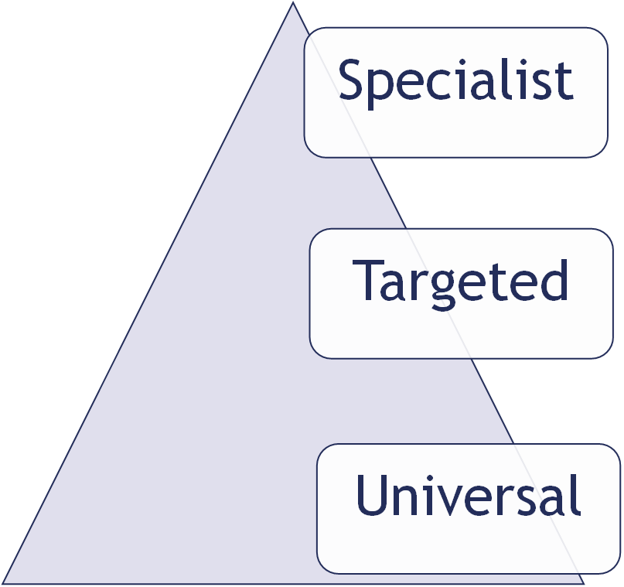

2. Whole-school audit template
- Leading Change
Action | Status | Notes
e.g. Have a named member of SLT with responsibility for attendance | ☐ achieved  ☐ working towards  ☐ not yet in place
☐ achieved
☐ working towards
☐ not yet in place

☐ achieved
☐ working towards
☐ not yet in place

☐ achieved
☐ working towards
☐ not yet in place

- Working together
Action | Status | Notes
e.g. Co-produced policy in place | ☐ achieved  ☐ working towards  ☐ not yet in place
☐ achieved
☐ working towards
☐ not yet in place

☐ achieved
☐ working towards
☐ not yet in place

☐ achieved
☐ working towards
☐ not yet in place

- Understanding need
Action | Status | Notes
e.g. CPD for all staff | ☐ achieved  ☐ working towards  ☐ not yet in place
☐ achieved
☐ working towards
☐ not yet in place

☐ achieved
☐ working towards
☐ not yet in place

☐ achieved
☐ working towards
☐ not yet in place

- Promoting wellbeing
Action | Status | Notes
e.g. School has trained Mental Health lead in place | ☐ achieved  ☐ working towards  ☐ not yet in place
☐ achieved
☐ working towards
☐ not yet in place

☐ achieved
☐ working towards
☐ not yet in place

- Supporting staff
Action | Status | Notes
e.g. All staff feel skilled and confident to recognise and support students with attendance concerns | ☐ achieved  ☐ working towards  ☐ not yet in place
☐ achieved
☐ working towards
☐ not yet in place

☐ achieved
☐ working towards
☐ not yet in place
☐ achieved
☐ working towards
☐ not yet in place

3. Assess, Plan, Do, Review Template

4. Layla completed formulation
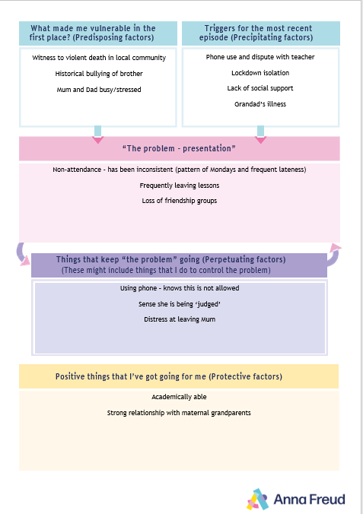
Notes:
____________________________________________________________________________________________________________________________________________________________________________________________________________________________________________________________________________________________________________________________________________________________________________________________________________________________________________________________________________________________________________________________________________________________________________________________________________________________________________________________________________________________________________________________________________________________________________________________________________________________________________________________________________________________________________________________________________________________________________________________________________________________________________________________________________________________________________________________________________________________________________________________________________________________________________________________________
_________________________________________________________________________________________________________________________________________________________________________________________________________________________________________________________________________________________________________________________________________________________________________________________________________________________________________________________________________________________________________________________________________________________________________________________________________________________________________________________________________________________________________________________________________________________________________________________________________________________________________________________________________________________________________________________________________________________________________________________________________________________________________________________________________________________________________________________________________________________________________________________________________________________________________________________________________________________________________________________________
_________________________________________________________________________________________________________________________________________________________________________________________________________________________________________________________________________________________________________________________________________________________________________________________________________________________________________________________________________________________________________________________________________________________________________________________________________________________________________________________________________________________________________________________________________________________________________________________________________________________________________________________________________________________________________________________________________________________________________________________________________________________________________________________________________________________________________________________________________________________________________________________________________________________________________________________________________________________________________________________________
_________________________________________________________________________________________________________________________________________________________________________________________________________________________________________________________________________________________________________________________________________________________________________________________________________________________________________________________________________________________________________________________________________________________________________________________________________________________________________________________________________________________________________________________________________________________________________________________________________________________________________________________________________________________________________________________________________________________________________________________________________________________________________________________________________________________________________________________________________________________________________________________________________________________________________________________________________________________________________________________________

